**TRAIN_SPAM_PROCESSED:**

1. Word Cloud.

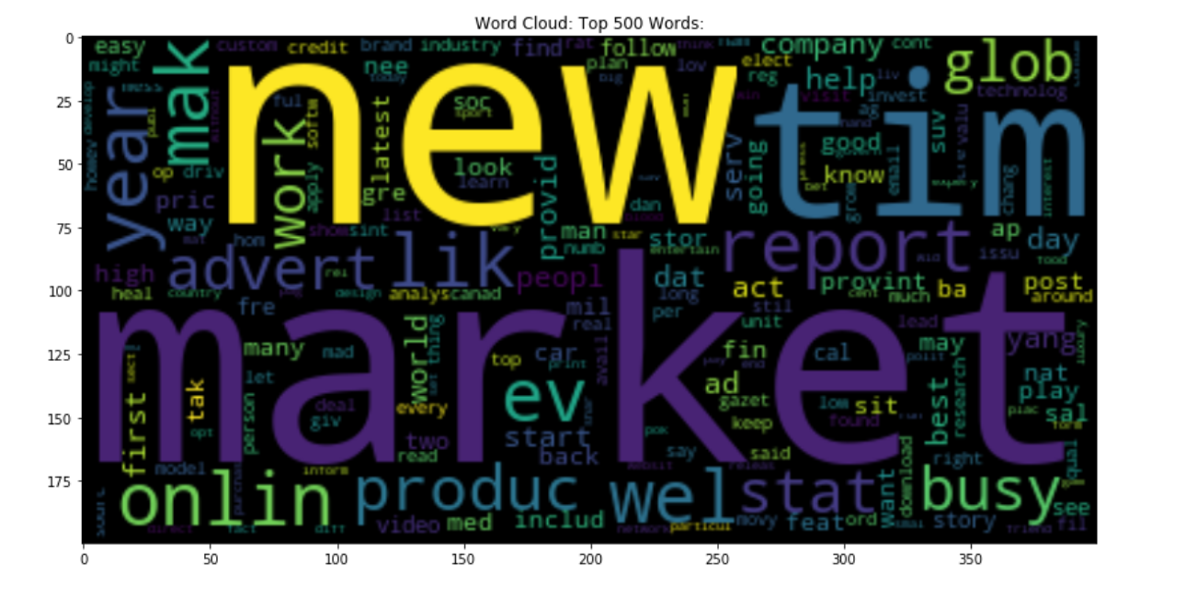

1. Top 50 Single Words.

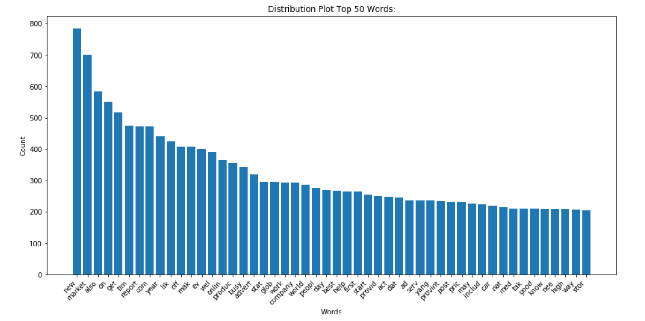

1. Top 50 Double Words.

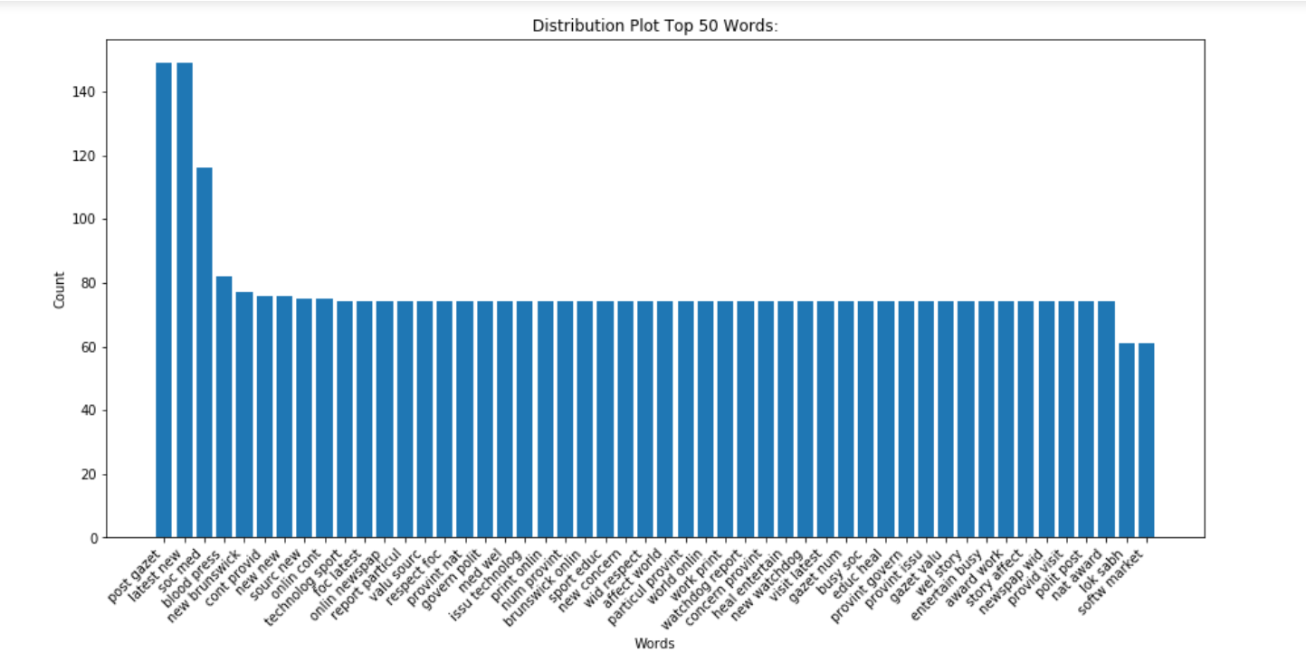

1. Top 50 Triple words.

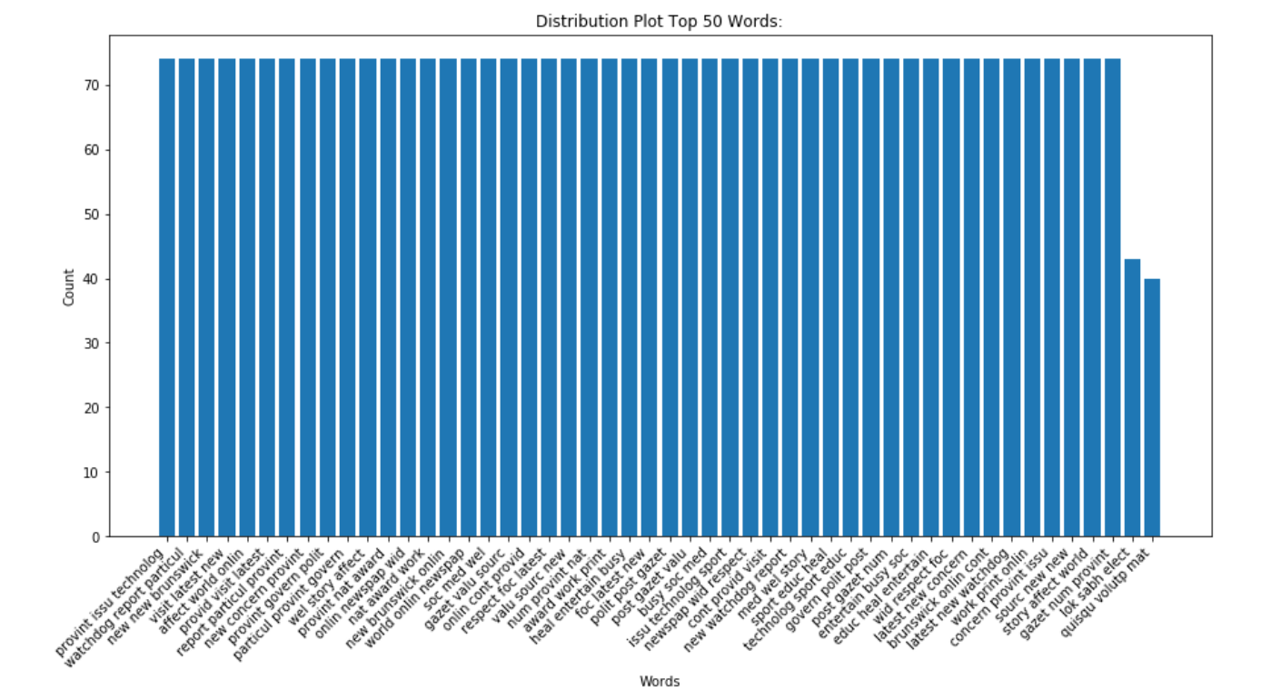

**TRAIN_SPAM_PROCESSED_POS:**

1. Word Cloud POS.

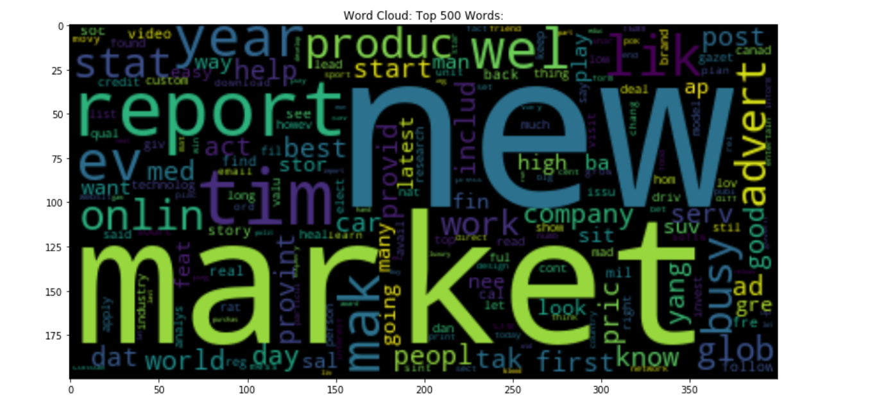

1. Top 50 Single Words POS.

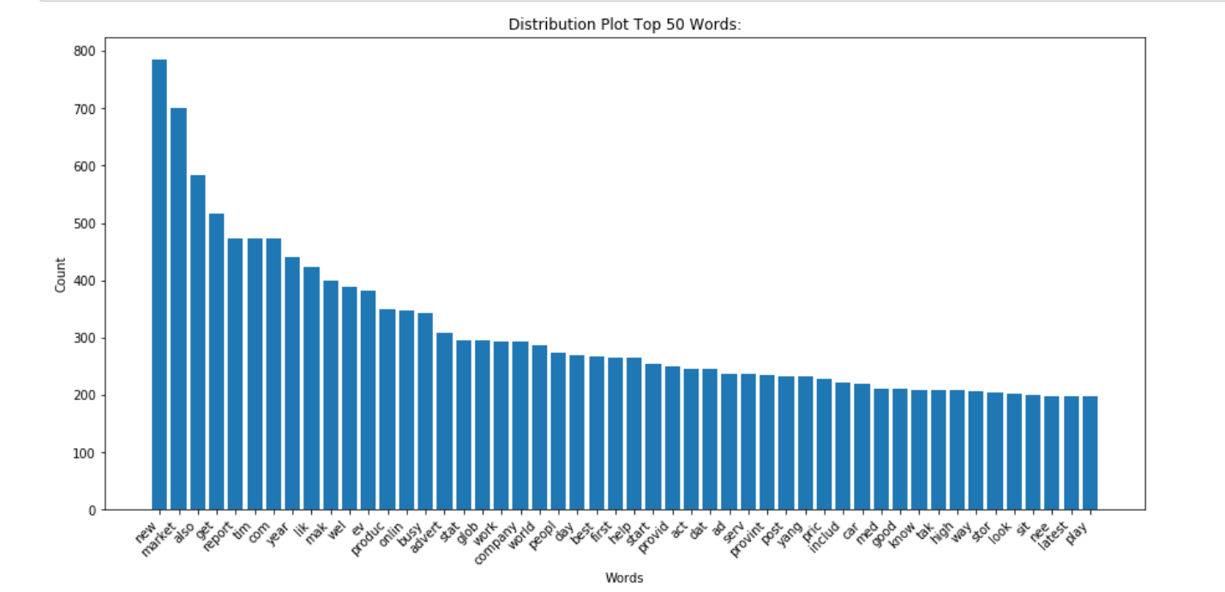

1. Top 50 Double Words POS.

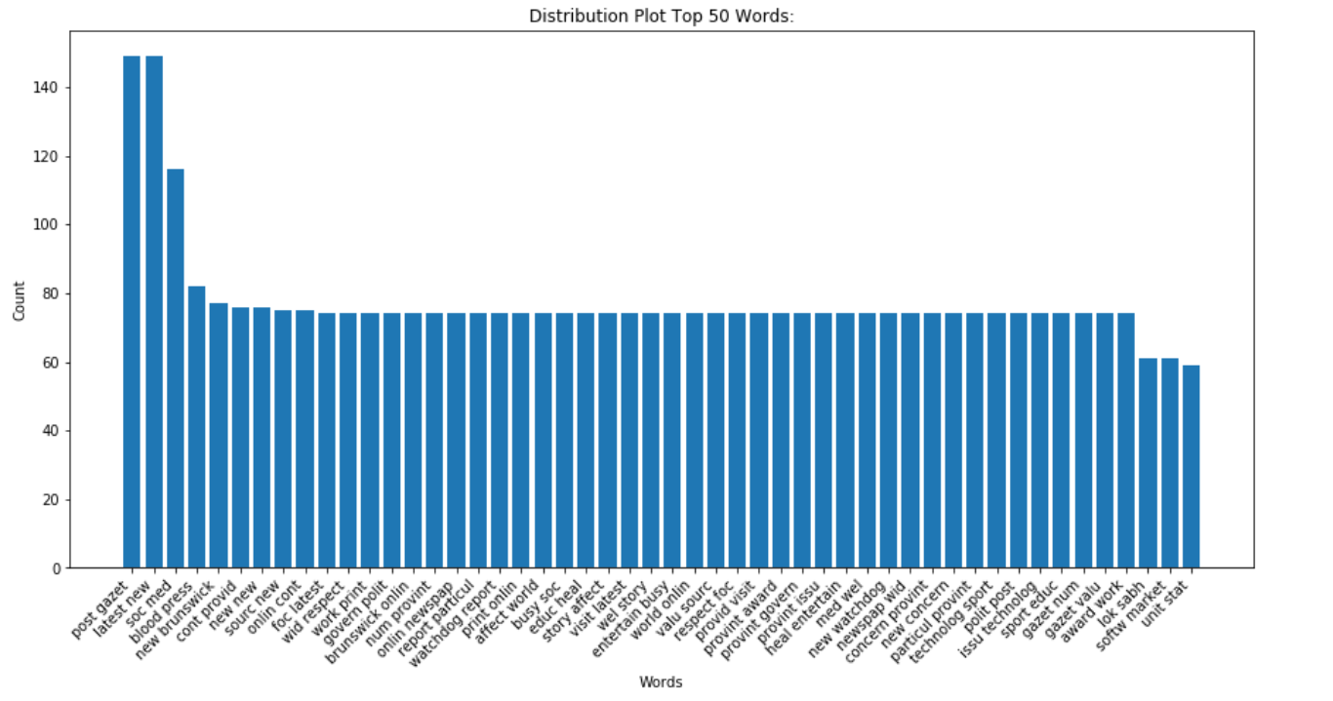

1. Top 50 Triple Words POS.

